


PJT03030.R5.SAP.FS.DPP. CRM.ENH.DPP.011 - Enrollment Center | 

REVIEWER(S)
Name | Title | Department | Reviewed (date/time)
Manoj Ajgaonkar | SAP Solution Architect | SAP |  | <Date / Time>
Jack Hobbick | Testing Solution Manager | Smart Energy Program |  | <Date / Time>
Santhosh Shetty | Testing Lead | HCL |  | <Date / Time>
Jessica Scott | Audit Controls, Deloitte | Deloitte |  | <Date / Time>
Clark Oeler | Audit Controls, Deloitte | Deloitte |  | <Date / Time>
Chaitanya Kodela | BTS SDM Solution Architect | BTS |  | <Date / Time>
Nancy Pierce | Business Support Consultant | Virtual Contact Center |  | <Date / Time>
Abhishek Bansal | SAP Solution Architect | SAP |  | <Date / Time>
Ramesh Swarna | HCL Technical Lead | HCL |  | <Date / Time>
Nilabja Guha | ESB Team Lead | CAP |  | <Date / Time>
John Lalicker | ESB Team | CAP |  | <Date / Time>
Alok Bedi | Grid Director | CAP |  | <Date / Time>
Brent Kassing | iFactor Lead | iFactor |  | <Date / Time>
Jason Iaccio | iFactor Team | iFactor |  | <Date / Time>
Craig Bialy | DRMS Lead | Lockheed Martin |  | <Date / Time>

APPROVER(S)
Name | Title |  | Department |  | Approval (date/time)
Clay Engel |  | Enrollment Vendor Program Manager |  | Smart Energy Program |  | <Date / Time>
Elody Samuelson |  | DPP Program Manager |  | Smart Energy Program |  | <Date / Time>
Krishna Karunakaram |  | Smart Energy Project Manager |  | Smart Energy Program |  | <Date / Time>
Jeff Yankley |  | IT-C&APS-IT App Portfolio-Front Office |  | BTS |  | <Date / Time>
Zach Pakkala |  | Business Support Consultant |  | Customer Operations/SE CORE |  | <Date / Time>
Blair Estep |  | CE Release Manager |  | Smart Energy Program |  | <Date / Time>

CONTRIBUTORS
Name | Organization | Area of Contribution
Abhishek Bansal | SAP America, Inc.
Matthew C. Parker | Consumer Energy
Ashish Bhargava | SAP America, Inc.

VERSION HISTORY
Version | Date | Author(s) | Revision Notes
0.1 | 11/03/2015 | Ashish Bhargava | Initial version
0.2 | 11/10/2015 | Ashish Bhargava | Final Version

Table of Contents

REVIEWER(S) 2
APPROVER(S) 2
1 OBJECT REQUIREMENT SUMMARY 5
1.1 Object Information and Attributes 5
1.2 Requirements Summary and Business Driver 6
1.3 Assumptions 6
1.4 Current Functionality 6
1.5 Required Functionality 6
1.6 Project / Development Constraints 7
1.7 Performance Criteria 7
1.8 Other Objects Affected 7
1.9 External References 7
1.10 Definitions/Acronyms/Abbreviations 7
2 ENHANCEMENT DESIGN SPECIFICATIONS 9
2.1 Custom Class 12
2.2 Standard Rule 12
2.3 Custom Table Creation 12
2.4 Work Item Delivery Requirements 12
2.5 Triggering Events Determination 12
2.6 Escalation Requirements 12
2.7 Dependencies 12
2.8 Error Handling Method 12
2.9 Post Execution Notification Details 13
2.10 Process Log Details 13
2.11 Other 13
2.12 Unit Test Plan 13
2.13 Information Security 13
2.14 Audit 14
2.15 Questions / Issues / Risks 14

OBJECT REQUIREMENT SUMMARY

Object Information and Attributes
The following is current information about this object and document:
Object ID | CRM_ENH_DPP_011
Title | PJT03030.R5.SAP.FS.DPP.ENH.011 – Enrollment Center
Team Which Owns the Object | DPP Enrollment SAP team
System Version | CRM 7.0
Development Type | Enhancement
Priority | High
Estimated Complexity | High
Link to Process Flow

Requirements Summary and Business Driver
This functional specification document covers in detail the various DPP Enrollment Processes and sub processes in regards to how the enrollment and de-enrollment is initiated and completed in SAP.

Requirement Id for this requirement
Ref. | PRICEFW ID | Enhancement Description
DPP-068 | CRM_ENH_DPP_004 | CSRs will have the ability to enroll customers in DPP (CPP and PTR) for both new move ins, and for already moved in customers. These enrollments will be offered to customers who have been previously enrolled in the DPP Program.

1.2.1 Alternatives to Object
The CE user would have to remember themselves to initiate DPP Enrollment request for the customer, manually investigate to identify if the account is considered eligible for DPP Enrollment.
Additionally, the CE user would have to remember to navigate to the Preference Center in CRM after the completion of a Move In, and update a mandatory preference for the DPP Enrollment.

1.2.2 Impact of Implementation
If implemented, CSRs will be able to easily identify customer program eligibility for the programs included in the Enrollment Center. Customer Program Enrollment and De-Enrollment will be initiated will be consistent for all programs included in the Enrollment Center.

1.2.3 Impact of No Implementation
If not implemented, there would be no automated system prompts in relation to Customer Program Enrollment/De-Enrollment. It would be on the user to have to remember to perform the required eligibility checks. They would have to manually navigate through the SAP system to perform these validations which would require a great deal of system navigation and increase call handling time.

Assumptions
Existing CSSD program will be modified to update the customer program enrollment through Enrollment Center in CRM. Functional Specification PJT03030.R5.SAP.FS.DPP.ENH.DPP.0012.Enrollment Center - CSDD.v0.1

Current Functionality
Currently Consumers Energy does not have any functionality which can display the list of customer programs in which customer is enrolled, eligible and ineligible.

Required Functionality
A new screen will be developed which will display all the program/services customer is eligible/Ineligible for, and/or enrolled. Following is the sample mock up screen design:

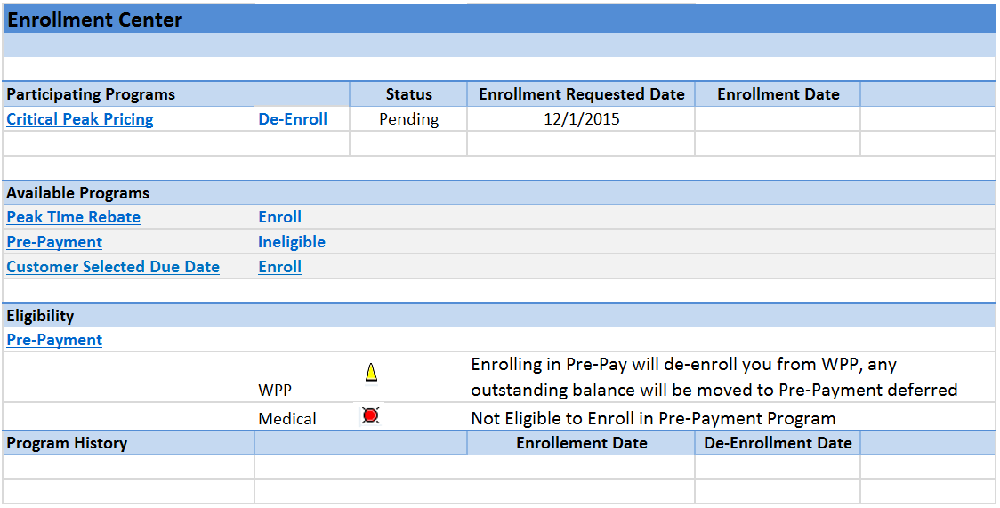

Before enrollment center is displayed; system will perform the eligibility checks for all the programs defined in Program Type table. For DPP related Eligibility check; please refer to Functional Specification PJT03030.R5.SAP.FS.DPP.ENH.DPP.001.DPP Enrollment Eligibility Details.v0.2. For CSDD related eligibility check please refer to Functional Specification PJT03030.R5.SAP.FS.DPP.ENH.DPP.012.Enrollment Center - CSDD.v.01. For Pre-Pay eligibility check please refer to Functional Specification PJT03030.R5.PrePay.FS.CRM_ENH_PPM_08_PrePay_Eligibility

Project / Development Constraints
None Identified.

Performance Criteria
None Identified.

Other Objects Affected
None Identified.

External References
None Identified.

Definitions/Acronyms/Abbreviations

Abbreviation | Description
EV | Enrollment Vendor
SAP | Systems, Applications & Products in Data Processing
DPP | Dynamic Peak Pricing
CRM | Customer Relationship Management SAP system
CE | Consumers Energy
CSR | Customer Service Representative
IC | Interaction Center
CPP | Critical Peak Pricing
PTR | Peak Time Rebate
CSDD | Customer Select Due Date

ENHANCEMENT DESIGN SPECIFICATIONS

This screen will be divided in 4 main components:
- Participating Customer Programs Area
- Available Customer Programs Area
- Customer Program Enrollment History Area
- Eligibility Area

Following is propose screen layout

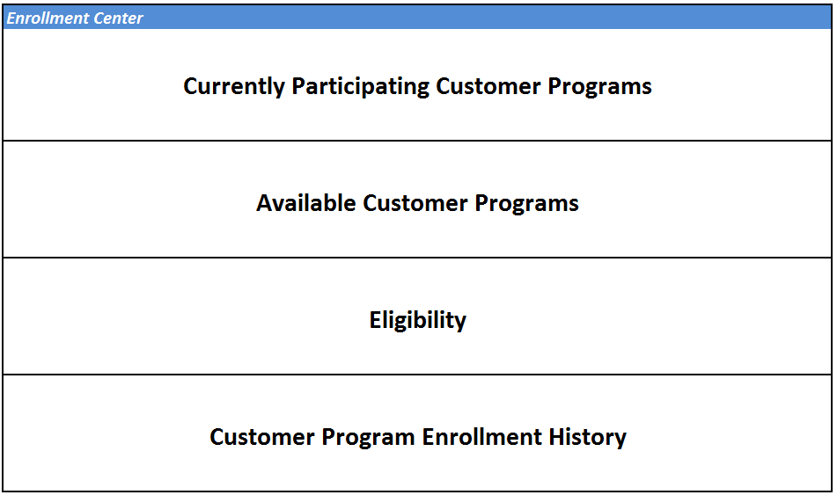

Program Definitions
A configuration table which is created as part of Functional Specification PJT03030.R5.SAP.FS.DPP.INT_DPP_003.DPP Enrollment Initiated by EV.v1.0 will be used to display the Program Types and Description. Following three new fields will be added to Program Type definition table.
Field Name | Key | Data Element | Data Type | Length | Description
PRIORITY |  |  | CHAR | 1 | Priority
VALID_FROM |  |  | DATS | 8 | Valid From
VALID_TO |  |  | DATS | 8 | Valid To
HISTORY_MO |  |  | NUMC | 2 | Months of Program History

Program Exclusion Table
Field Name | Key | Data Element | Data Type | Length | Description
MANDT | X | MANDT | CHAR | 3 | Client
PROG_TYPE | X | ZPROG_TYPE | CHAR | 4 | Program Type
EXCL_PRGM_TYPE | X | ZPROG_TYPE | CHAR | 4 | Exclusion Program
AUTO_DEENROLL |  | CHAR | CHAR | 1 | De-Enroll Processing
ERNAM |  | ERNAM | CHAR | 12 | Name of Person who has created the record
ERDAT |  | ERDAT | DATS | 8 | Date on which record was created
ERTIM |  | ERTIM | ERZET | 6 | Entry Time

Calling Program
This screen will be called from the Navigation Bar and a new work center will be added to existing Navigation Bar Profile.

Screen Layout
All the programs displayed on the screen will have a hyper link functionality which will display a short description of the customer program in a pop-up window (Business to provide the short description for all the programs). An action will be add after the program description which will take user directly to an initial screen of respective customer program enrollment screen. De-Enrollment process will only provide a confirmation pop-up and de-enrollment will be performed in the background. For example: If user clicks on Peak Time Rebate under Participating Sections. System will initiate the De-Enrollment as per the Functional Specification PJT03030.R5.SAP.FS.DPP.ENH.DPP.008.De-Enrollment Process.v.01.

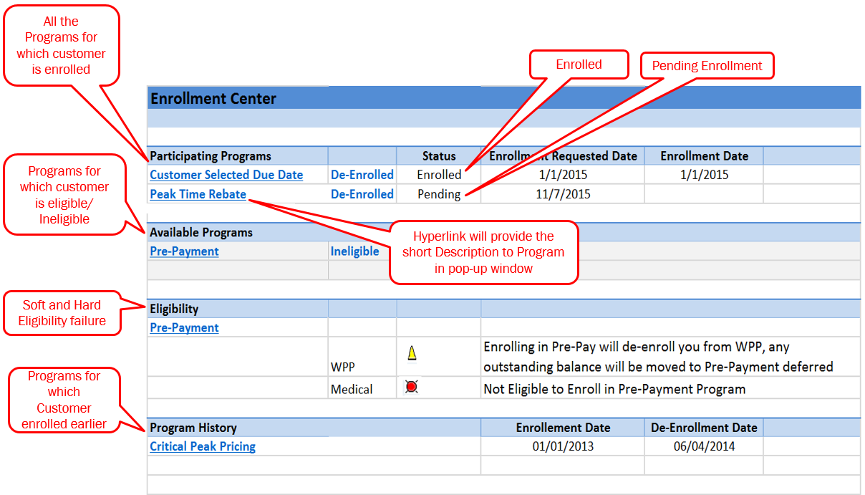

Following is just the sample of pop-up window which will display the program short description:

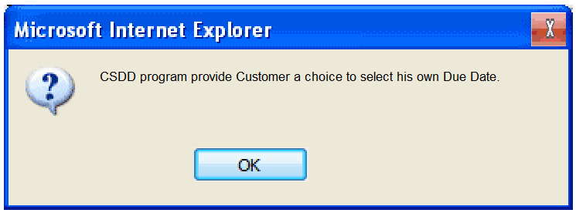

Data Selection Logic for each Section
For Participating Program and Available Program sections an action hyperlink will be dynamically created.
- Participating Programs
Will display all the programs in which a customer is enrolled or Pending Enrollment. Select all the programs from the Program Enrollment table which are in status “Pending” and “Enrolled”.
Enrollment Status | Action or Button
Enrolled | De-Enroll Action
Pending | De-Enroll Action

- Available Programs
This section will display all the programs for which customer is eligible as well as ineligible. Program validity dates will be check for to insure that only active programs are considered.
- Select all the programs from the Program Type table which are valid as of today.
- Perform the eligibility checks for all the programs which are maintained in Program Type table.
- In case the customer is ineligible in a program, clicking the hyper link or corresponding “Ineligible” button, will display the failed Eligibility conditions.
Eligibility Results | Action or Button
Eligible | Enroll Action
Ineligible | Ineligible Action to display the failed eligibility condition

- Customer Program History
This section will display the customer’s enrollment in past. The program type definition table will maintained the “Number of Months” for which program history needs to be displayed. Select all the programs from the Enrollment table which are in status de-enrolled or cancel.
- Eligibility
This section will display the eligibility criteria which failed the check.
- Soft Eligibility Failure- For example a customer is enrolled in PTR and CSR try to enroll him in CPP.
- Hard Eligibility Failure – For example, CSR try to enroll a customer in CPP Program and customer does not have smart meter.

Technical Details
A configuration table will be created to maintain the logical links for the Enrollment/De-Enrollment or any other links needs to be maintained for Enrollment Center. Following is the table design:

Field Name | Key | Data Element | Data Type | Length | Description
MANDT | X | MANDT | CHAR | 3 | Client
PROG_TYPE | X | ZPROG_TYPE | CHAR | 4 | Program Type
PROCESS_TYPE | X |  | CHAR | 2 | 01 – Enrollment, 02-De-Enrollment
LOGICAL_LINK |  | CRMT_UI_LOGICAL_LINK_ID |  |  | Logical Link for Enrollment/De-Enrollment

Custom Class
None Identified.

Standard Rule
BRF+ function developed for eligibility check for DPP and Pre-Pay will be called before the enrollment center is displayed. Following are the Functional Specification for Eligibility:
- PJT03030.R5.SAP.FS.DPP.ENH.DPP.001.DPP Enrollment Eligibility Details.v0.2.
- PJT03030.R5.PrePay.FS.CRM_ENH_PPM_08_PrePay_Eligibility

Custom Table Creation
There will be a new table created to maintained the Program Exclusion. This is the configuration table which can be maintained by the Business Users like Program Managers.

A configuration table will be created to maintain the logical links for enrollment and de-enrollment for each program. Only IT will maintain this table and should be maintained once the enrollment center is developed and new program is added in future to the enrollment center.

Work Item Delivery Requirements
None Identified.

Triggering Events Determination
None identified

Escalation Requirements
None Identified.

Dependencies
- PJT03030.R5.SAP.FS.DPP.ENH.DPP.004.Enrollment Processes.v0.1
- PJT03030.R5.SAP.FS.DPP.ENH.DPP.008.De-Enrollment Process.v.01
- PJT03030.R5.SAP.FS.DPP.ENH.DPP.012.Enrollment Center - CSDD.v.01
- PJT03030.R5.PrePay.FS.CRM_ENH_PP_01.PrePay.CRM.Enrollment.v01

Error Handling Method
None Identified.

Post Execution Notification Details
None Identified.

Process Log Details
None Identified.

Other
None Identified.

Unit Test Plan

Information Security
Please see below.

Information Classification
None Identified.

Security Roles (Profiles and Authorizations)
Following Business Role will have authorization to the Enrollment Center.
Business Role Name | Role Description
ZIC_BKOF | Customer Billing Bus. Role (4)
ZIC_CSR1 | CSR I Business Role (1)
ZIC_CSR2 | CSR II Business Role (2)
ZIC_CSR3 | CSR III Business Role (3)
ZIC_CSRX | Outsource CSR Business Role-10
ZIC_VCC | VCC Mgmt. Bus. Role (9)
ZIC_RVRC | Revenue Recovery Bus. Role (5)
ZCRM7_BRC | CSR III B. Role - BRC Switch
ZCRM7_PRM | CSR III B. Role - PRM Switch
ZIC_BCOP | Business Ctr. Bus. Role (7)
ZIC_TRAINING | Training Dept. Bus. Role (0)

Table Security (if applicable)
Please see the section 2 for the custom table and the authorization.

ABAP Program Security (if applicable)
None Identified.

Audit
None Identified.

Questions / Issues / Risks
None Identified.

